The American Community School
Yearbook

AL-MANARA
2005-2006
Experiment. Create. Innovate.

Dear Parents of 2006 Graduates,

The yearbook staff of the American Community School at Beirut is, for the first time in the history of the school, offering parents the opportunity to express their love and congratulations to their graduating senior in the yearbook.*
The “Parent Tribute” section in Al-Manara gives you a place to display pictures of your son/daughter along with a special message from you and your family. There is limited space, so hurry and turn in your dedication as soon as possible.
You can buy a quarter, a half, or a full page. A sample of the pages is attached to this letter. The sizes and rates are shown below.

* PS: Participation is in no way required and your son or daughter will still have their traditional space in the Yearbook for their own comments and photos.

Page Sizes and rates:
Full Page 18 cm width x 27 cm height $300
Half Page 18 cm width x 13.4 cm height $150
Quarter Page 9 cm width x 13.4 cm height $75

Production: Digital files may be submitted in the following software formats:
- Microsoft Word
- Adobe InDesign (CS or CS2)
- Adobe Illustrator (8.0, 9.X)
- Adobe Photoshop (8.0)*
- TIFF (not jpg)
*Please use a resolution of 300ppi.

Miscellaneous:

- Spaces are filled on a first come, first served basis.
- Only one dedication per student is allowed, so concur with all interested family members before submitting.
- Deadline for Parent Tribute space purchasing: January 27, 2006. You can pay at the cashier’s office at ACS, and you will receive a receipt with the amount of money you have paid.
- Complete dedications must be received no later than Friday, February 17, 2006.
- Please submit files on CD to Miss Mony Kfoury, the administrative assistant of Mr. Tom Oden. Do not forget to write your son/daughter’s name on the CD.
- You need to do the layout of your dedication yourself on MS Word. All fonts and individual graphic image files (TIFF format, 300ppi) must be submitted along with the main file. A hard-copy color digital proof must accompany the file.
- No negatives accepted.
- Do not use/send more pictures than the selected layout will hold. If you send more, we will not notify you of the mistake and choose the pictures we think are best. If you don’t send enough pictures, there will be a blank spot in your dedication.
- The yearbook staff reserves the right to remove any text or graphics that they might consider inappropriate for the yearbook.
- The yearbook staff will make every possible effort to read digital files submitted in the formats listed above. However, the staff and ACS will not be responsible for incomplete or unreadable files. If you need design services or assistance with creating camera-ready art please contact Mrs. Nada Abi Samra (Yearbook Adviser) or Joumana Al Rashed (Yearbook Editor-in-Chief) for information.

Should you have any questions or wish to discuss this further, do not hesitate to contact Mr. Tom Oden at 01-374370, ext. 175 or Mrs. Nada AbiSamra at 01-374370, ext. 199 or even email us at yearbook@acs.edu.lb.

Sincerely,

_________________ ________________
Nada AbiSamra Tom Oden
Yearbook Adviser High School Principal
SAMPLE: FULL PAGE TRIBUTE

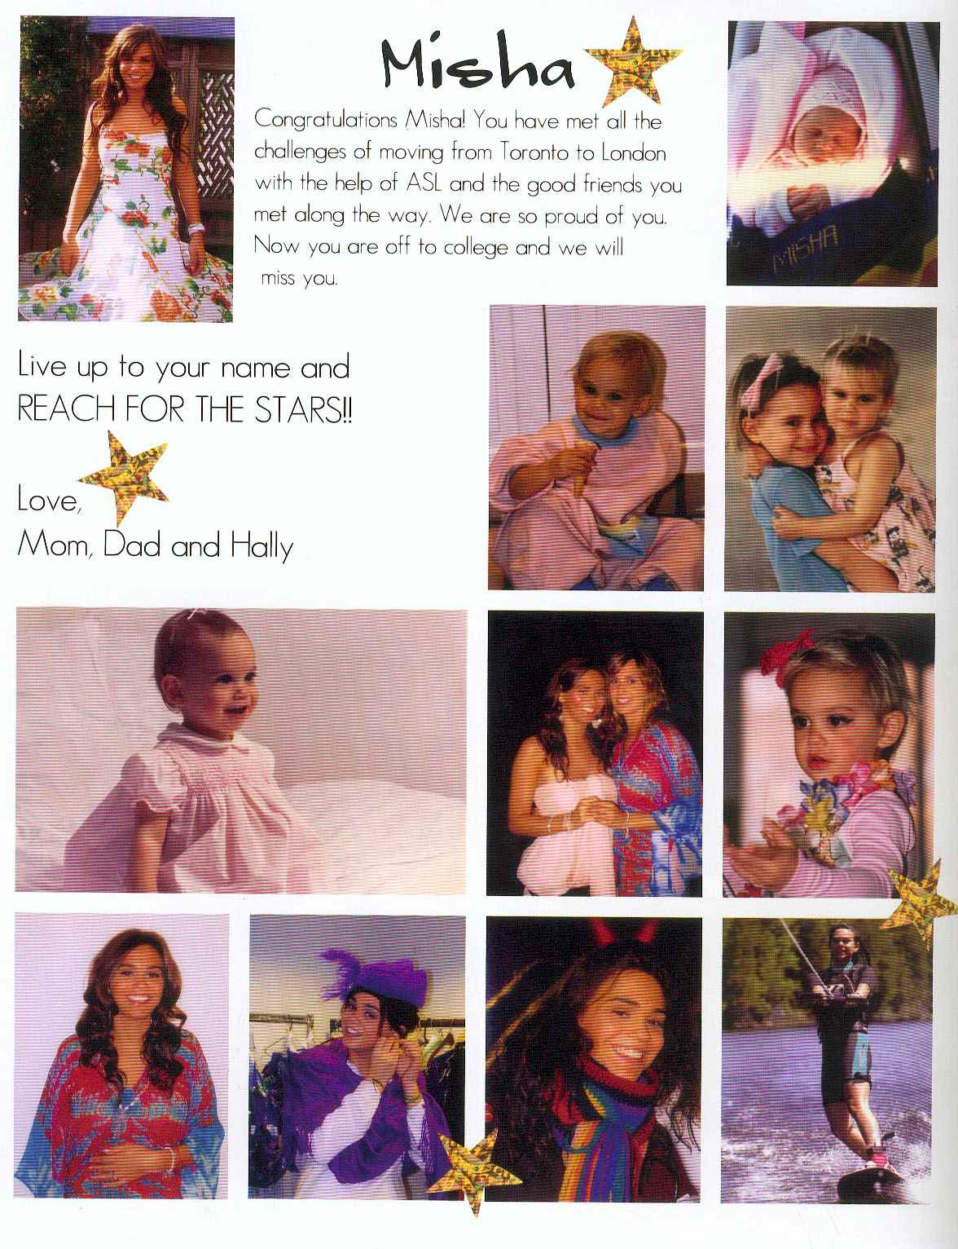

SAMPLE: HALF PAGE TRIBUTES

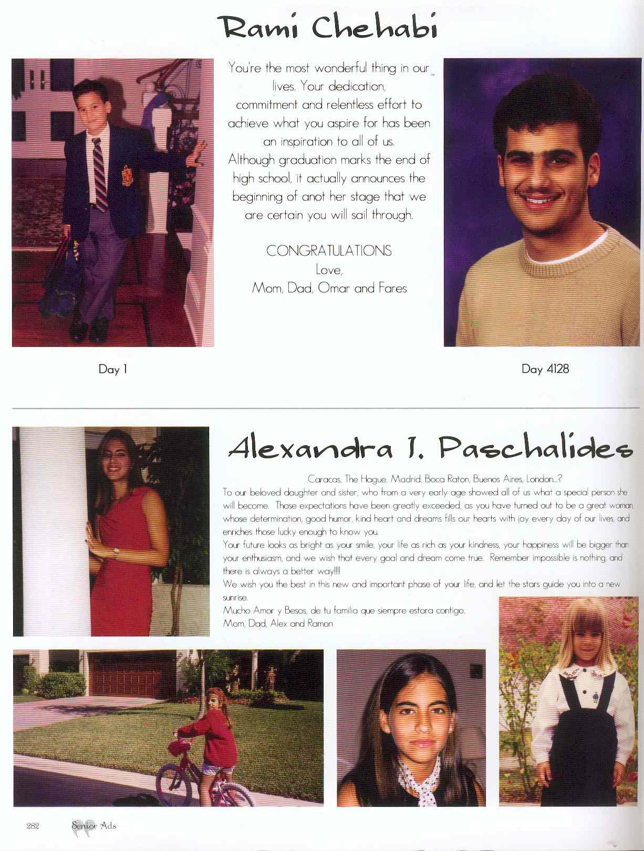
SAMPLE: QUARTER PAGE TRIBUTES

